MECHATRONIC SYSTEM INTEGRATION
(MCTA 3203)
SEMESTER 1, 2026/2027
EXPERIMENT 2
SERIAL COMMUNICATION
(MCTA 3203)
SECTION 1
GROUP 12
NO. | MATRIC NO. | NAME
1 | 2410405 | MUHAMMAD FATHI BIN MUHAMMAD SABRI
2 | 2217461 | TAHSIN TAHMID
3 | 2414951 | MUHAMMAD SYAHRUL BIN OMAR NAGESWARAN

SUBMISSION DATE: 19th OCTOBER 2026

ABSTRACTS

This experiment investigates the use of asynchronous serial communication between an Arduino microcontroller and Python for mechatronics system integration. Data is exchanged bidirectionally via USB serial interface by utilizing the pyserial library.

In Task 1, Arduino receives the analog sensor signals from the potentiometer and transmits it continuously to the Python script for real-time monitoring and data logging. Furthermore, logical control is established through Python by processing incoming data to conditionally actuate an external LED based on a predetermined threshold (exceeding half of the sensor’s maximum range). Task 2 extends from task 1 by adding servo motor to the circuit to read and execute movements according to Python script via potentiometer input. Task 3 elevates the test further by adding LED and controlling its light output binarily alongside the servo motor’s angle movements from the potentiometer input.

All 3 task are run to prove the reliability of Python-Arduino serial interfacing, providing structure for software-hardware architecture essential for PC-based data visualization, monitoring, and closed-loop control in mechatronic systems.

TABLE OF CONTENTS

Section | Content | Page
1 | Cover Page | 1
2 | Abstracts | 2
3 | Table of Contents | 2
4 | PART 1: Experiment 1 & Task 1 Reading Potentiometer Values via Serial Communication | 3-6
5 | PART 2&3: Controlling Servo Motor via Serial Communication | 6-14
6 | Recommendation | 15
7 | References | 15
8 | Appendices | 15-20
9 | Acknowledgement | 21
10 | Student Declaration | 21-22
PART 1: Experiment 1 & Task 1 Reading Potentiometer Values via Serial Communication

1.0 INTRODUCTION & THEORY

A key protocol in mechatronic systems for data transfer between microcontrollers and host PCs is serial communication. This experiment uses a USB physical connection for asynchronous serial transmission via Universal Asynchronous Receiver-Transmitter (UART). A potentiometer, a three-terminal variable resistor that functions as an adjustable voltage divider, is the main sensor used. The 10-bit Analog-to-Digital Converter (ADC) included into the Arduino maps input voltages between 0 and 5V over an integer range between 0 and 1023 ($2^{10}-1$).
The system uses a USB serial connection set to a 9600 baud rate to send ADC telemetry. To deliver digital control signals to an LED, a Python script on the host computer uses the pyserial package to receive incoming string packets, transforms them into numeric data types, and evaluates threshold logic.
Hypothesis: The potentiometer's continuous analogue voltage measurement will produce a linear output mapping from 0 to 1023. When the value surpasses half-scale (ADC > 511), the host Python script will parse these incoming packets via UART and correctly turn on an LED, maintaining execution stability without buffer overflow when throttled suitably.

1.1 MATERIALS AND EQUIPMENT

- Arduino board
- Potentiometer
- Jumper wires
- Breadboard
- LED (Standard 5mm Red)
- 220 ohm Current-Limiting Resistor
- PC with Python Environment (pyserial) and Arduino IDE

1.2 EXPERIMENTAL SETUP

1.2.1 Pin Connection Details
- Potentiometer Pin 1 (Outer): $5V$ on Arduino
- Potentiometer Pin 2 (Center Wiper): Pin $A0$ (Analog Input) on Arduino
- Potentiometer Pin 3 (Outer): $GND$ on Arduino
- LED Anode (+): Pin $D13$ on Arduino through a $220Ω$ resistor
- LED Cathode (-): $GND$ on Arduino

1.2.2 Hardware Configuration Instructions
- Mount the potentiometer and LED on the breadboard.
- Connect the outer pins of the potentiometer to $5V$ and $GND$ rails. Connect the wiper to analog pin $A0$.
- Insert the $220Ω$ current-limiting resistor in series with the LED anode and wire it to digital pin $D13$. Connect the LED cathode directly to common ground.
- Connect the Arduino Uno to the host computer using the USB cable.

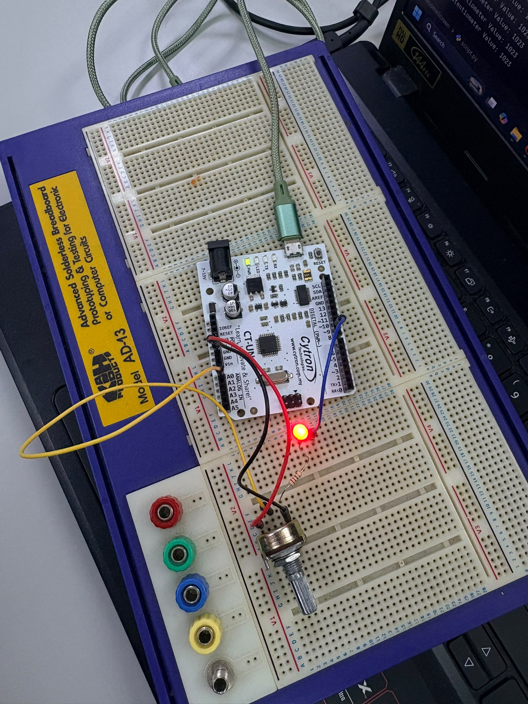
Figure 1.2: Circuit Assembly Diagram

1.3 METHODOLOGY & PROGRAMMING LOGIC

- As directed by the pin connection instructions, assemble the hardware circuit on the breadboard.
- Using the Arduino IDE, flash the C++ firmware onto the Arduino board.
- To avoid serial port lockouts, confirm that the Arduino Serial Monitor/Plotter is closed.
- To open the serial port at 9600 baud, run the Python script.
- Check that the values appear in the Python terminal and that the LED turns on when the potentiometer dial is turned to its full range.

1.4 DATA COLLECTION & ANALYSIS

Knob Rotation | Equivalent Voltage (Vin) | ADC Value  (0 - 1023) | LED State | Terminal Output  (Potentiometer Value)
Minimum  (0 degree) | 0.00 V | 0 | OFF | 0
Low  (45 degree) | 1.25 V | 255 | OFF | 255
Midpoint  (90 degree) | 2.50 V | 511 | OFF | 511
Threshold  (91 degree) | 2.53 V | 518 | ON | 518
High  (135 degree) | 3.75 V | 767 | ON | 767
Maximum  (180 degree) | 5.00 V | 1023 | ON | 1023

1.4.1 Technical Signal Handling Analysis

The 10-bit analog-to-digital converter uses discrete quantisation steps to process continuous voltages:
$ΔV=\frac{V_{ref}}{2^{10}}=\frac{5.00V}{1024}≈4.883mV/step$
The system demonstrates a linear transfer function:

$ADCOutput(V_{in})=round\left(204.6×V_{in}\right)$
The computed quantisation value at $V_{in}=2.50V$ is $511.5$. The LED status is precisely toggled at half-scale by the discrete threshold boundary set at $511$, which produces a clear step shift in the digital control logic.

1.5 RESULTS & DISCUSSION

1.5.1 Performance Analysis vs. Hypothesis

The empirical output matched the theoretical predictions. Data frame reception via pyserial operated smoothly without dropped bytes or parsing failures due to the $100ms$ delay in the microcontroller firmware.

1.5.2 Error Sources & Signal Noise Analysis

- Quantisation Uncertainty: The 10-bit ADC's $±0.5LSB$ rounding limit results in a voltage uncertainty of roughly $±2.44mV$.
- Supply Rail Fluctuations: $V_{ref}$ is directly impacted by USB power fluctuations ($4.75V$ to $5.25V$), causing slight scaling variations in ADC computations.
- Mechanical Contact Resistance: During fast manual turning, microscopic irregularities along the potentiometer carbon track cause transient noise spikes.

Video Evidence: Video Evidence of Experiment Task 1

1.6 CONCLUSION

Serial connectivity between an Arduino Uno and a Python environment was successfully confirmed in Experiment 1 Task 1. The potentiometer's analogue voltage output was converted to a 10-bit range ($0-1023$) and sent at 9600 baud via UART. The status LED was consistently controlled by half-scale thresholding ($>511$), confirming fundamental sensor acquisition, serial packet transmission, and threshold evaluation.

2.0 INTRODUCTION & THEORY
This section of the experiment establishes a supervisory control system where a host computer sends manual commands to a microcontroller via a USB serial connection. The primary objective is to control the angle position of a 180 degree servo motor with the help of a python script. The python script will ask the user for inputs in the range of 0-18-0 degrees and it will adjust the angular position of the servo motor based on the feedback from the user. This function is completed by the arduino by receiving data packet and translating it into physical movement using PWM(Pulse Width Modulation).
Hypothesis: The user will input any valid integer between the number of 0 and 180 in the python terminal and that will cause the servo motor to actuate to that exact degree. However, with the input of the character ‘q’ the serial connection will be terminated and the loop will be broken.
2.1 MATERIALS AND EQUIPMENT
- Microcontroller (Arduino Uno)
- Standard 180-Degree Servo Motor
- Jumper Wires
- PC with Python Environment (pyserial) and Arduino IDE
2.2 EXPERIMENTAL SETUP
- Servo Connection: Connect the servo's VCC (red wire) to the 5V pin on the Arduino, and the GND (brown/black wire) to the Arduino GND.
- Signal Connection: Connect the servo's PWM signal wire (yellow/orange) to Arduino digital pin 9.
- Interface: Connect the Arduino to the PC via USB and verify the assigned COM port.
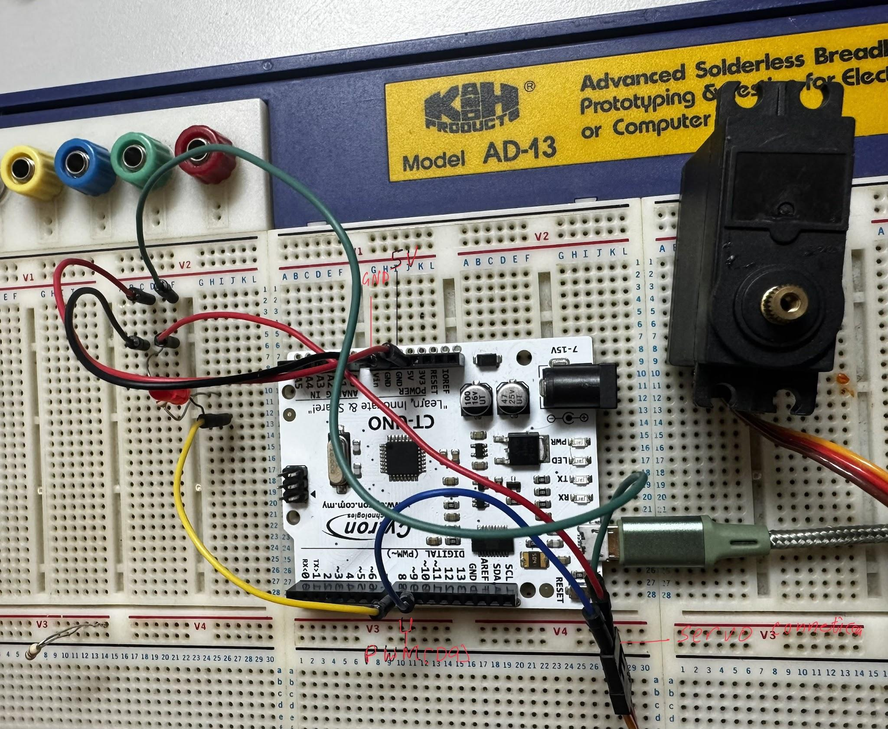
Fig: 1.3: Circuit Assembly Diagram
2.3 METHODOLOGY & PROGRAMMING LOGIC
The system relies on bidirectional command parsing between the computer and the microcontroller:
Python: The python script opens the COM using the serial library at a baud rate of 9600. With the while True: loop and the input() function it continuously asks the user for an angle input. If the input is a valid integer between 0 and 180, it is encoded into bytes and sent to the Arduino via ser.write(). If the input is 'q', a break statement triggers, and a finally block safely closes the port (ser.close()).
C++:Arduino initializes the serial port and attaches the servo to pin 9 and uses the function of Serial.available() to look for incoming inputs and keys, when it reads data it parses the integer and writes out myservo.write() to get to motor to the desired position.
2.4 DATA COLLECTION & ANALYSIS
Observed System Responses to Manual Python Inputs:
Python Terminal Input | Data Type Sent | Arduino / Servo Response
0 | Encoded String/Integer | Servo snaps to the 0° home position.
90 | Encoded String/Integer | Servo rotates to the center 90° position.
180 | Encoded String/Integer | Servo rotates to the maximum 180° position.
45 | Encoded String/Integer | Servo rotates to the 45° position.
q | Character | Python loop breaks; serial connection closes cleanly.
2.5 RESULTS & DISCUSSION
The manual serial control system operated successfully. When valid angles were entered into the Python terminal, the servo motor actuated to the precise coordinates instantly. The Python script's built-in error handling (if 0 <= angle <= 180:) proved highly effective; it caught out-of-bounds commands before they were transmitted over the serial port, successfully protecting the hardware from attempting to drive past its physical mechanical limits. Furthermore, the Keyboard Interrupt and 'q' commands successfully severed the connection without crashing the Python environment.
Video Evidence: Video Evidence of Experiment 2

2.6 CONCLUSION
This phase of the experiment successfully demonstrated direct PC-to-microcontroller hardware control. By integrating Python's input-handling capabilities with the Arduino's PWM outputs, a reliable and safe interface was established to manually command mechatronic actuators via serial transmission.

3.0 INTRODUCTION & THEORY
In this section of the experiment, the setup was upgraded from manual keyboard inputs to continuous, real-time hardware control. A potentiometer was used as an analog sensor (0-5V) to dynamically adjust the servo motor's angle. The Arduino reads this voltage, converts it into a digital value (0-1023) using its internal ADC, and maps it proportionally to a 0-180 degree angle for the servo. The arduino uses its internal ADC to convert the voltage it reads into digital signals(0-1023) and maps it proportionately to the angular positions,
As a method of receiving physical feedback, an LED was programmed to turn on when the potentiometer is turned from its midpoint. During this time the arduino sends its data over to the python script which then plots the data into a real time graph using the matplotlib function. And lastly a safety function has been incorporated so that the pressing of a designated button will cause the loop to stop.
Hypothesis: Turning the potentiometer knob will cause the servo motor to move proportionally in real-time. The LED will light up when the sensor value crosses the halfway mark, and the computer monitor will display a live graph of the sensor readings without significant lag.
3.1 MATERIALS AND EQUIPMENT
- Microcontroller (Arduino Uno)
- Standard 180-Degree Servo Motor
- Potentiometer (10kΩ)
- LED (Standard 5mm Red)
- 220Ω Resistor
- Breadboard and Jumper Wires
- PC with Python (pyserial, matplotlib) and Arduino IDE
3.2 EXPERIMENTAL SETUP
- Potentiometer: Connect the outer pins to 5V and GND. Connect the middle wiper pin to Arduino analog pin A0.
- Servo Motor: Connect the power wires to 5V and GND, and the PWM signal wire to digital pin 9.
- LED: Connect the long leg (anode) to digital pin 8 through a 220Ω resistor, and the short leg to GND.
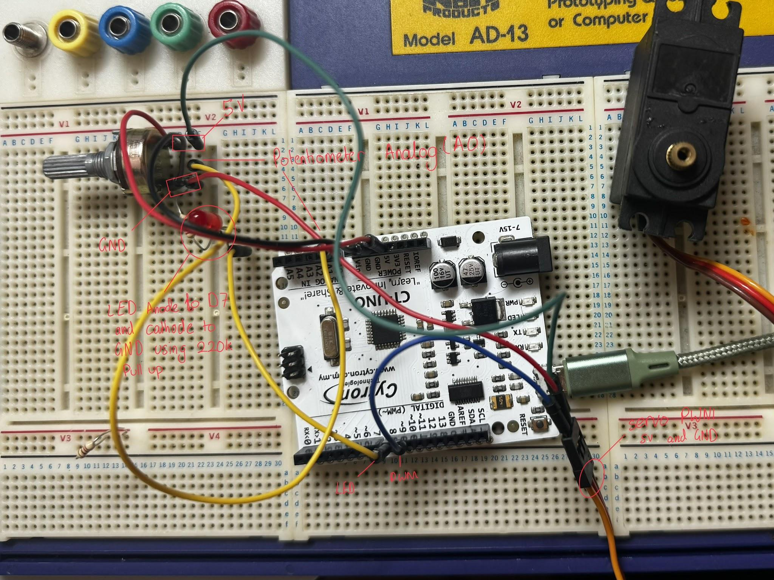
Figure 3.1: Circuit assembly for potentiometer and LED integration.
3.3 METHODOLOGY & PROGRAMMING LOGIC
- Arduino Firmware (C++): The loop is continuously looking for analog data from A0 and the map() function converts the 0-1023 readings into a 0-180 value, and then it further uses myservo.write function to write it out to the servo and actuate it. Another if statement is nested into the code so that when the value exceeds 512 then pin D8 is set high and the visual feedback LED is turned on, And the reading is then printed onto the serial monitor and the code also checks for a incoming’q’ and if it receives it then a boolean flag stops the motor and turns off the LED.

- Python Script: Matplotlib is used to plot the data that the script receives. To stop the graph from freezing or lagging due to too much data, the script was modified to use a sliding window (only keeping the most recent 50 data points) and a fixed Y-axis from 0 to 1024. A KeyboardInterrupt (Ctrl+C) triggers the script to send the 'q' halt command back to the Arduino.

3.4 DATA COLLECTION & ANALYSIS
System Response to Potentiometer Adjustments:
Potentiometer Position | ADC Reading (0-1023) | Servo Angle (Mapped) | LED State (>512)
Fully Counter-Clockwise | 0 | 0° | OFF
Quarter Turn | 255 | 45° | OFF
Halfway Turn | 511 | 89° | OFF
Just Past Halfway | 518 | 91° | ON
Fully Clockwise | 1023 | 180° | ON

3.4.1 Technical Signal and Actuation Analysis
The continuous input voltage from the potentiometer wiper, $V_{in}$ (0 to 5.00V), is processed by the microcontroller's 10-bit Analog-to-Digital Converter (ADC). The system quantizes this voltage into discrete digital steps based on the reference voltage:

$Resolution=\frac{V_{ref}}{2^{10}-1}=\frac{5.00V}{1023}≈4.887mV/step$
The digital $ADC_{value}$ is determined by the linear transfer function:
$ADC_{value}$(Vin)= ((Vin/5.0V)x1023)
To actuate the 180-degree servo motor, this 10-bit control signal ($0-1023$) must be scaled down to match the physical mechanical limits of the motor ($0^{∘}-180^{∘}$). The firmware executes this via a linear mapping algorithm:
Angle= ($ADC_{value}$x180)/1023
This transfer function yields an effective mechanical angular resolution of:

$\frac{180^{∘}}{1023}≈0.176^{∘}/step$
This demonstrates that for every $4.887mV$ change at the analog pin, the system computes a theoretical position shift of $0.176^{∘}$. The digital logic sets the LED feedback threshold at an ADC value of 512, which strictly correlates to a physical actuation angle of $90^{∘}$.

3.5 RESULTS & DISCUSSION
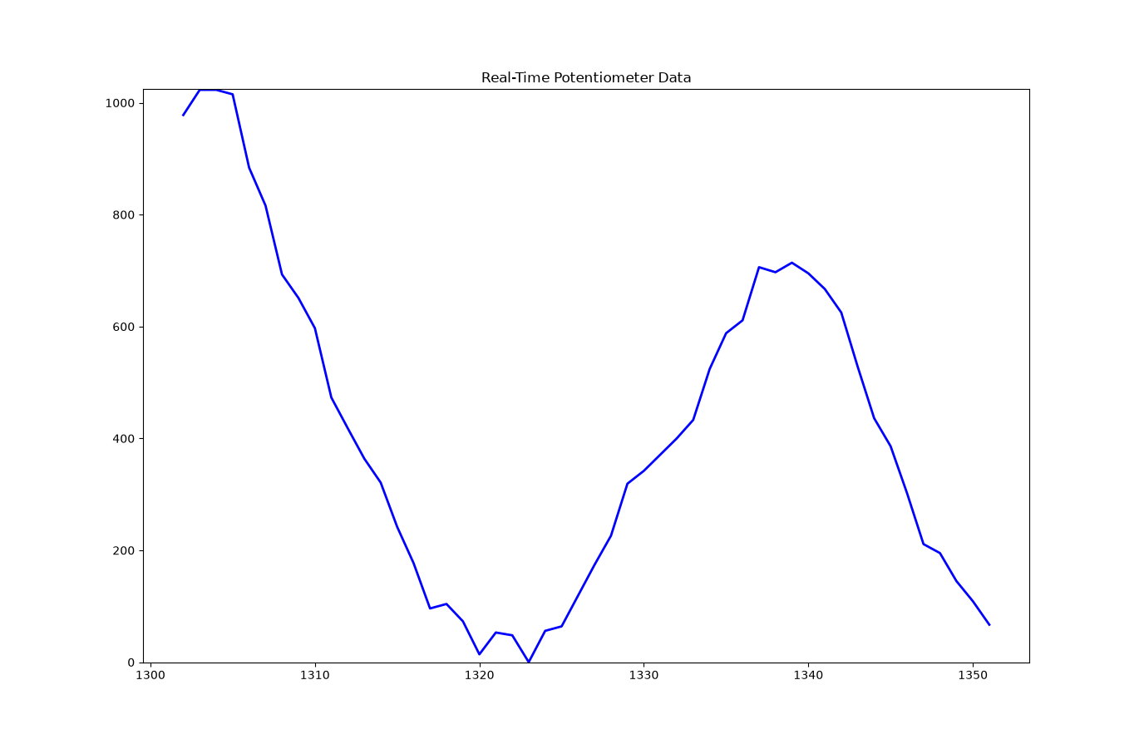
Figure 3.2: Real-time matplotlib visualization of continuous potentiometer ADC readings (0-1023).
Everything worked pretty much as planned. The servo moved in sync with the potentiometer, and the LED lit up exactly when we turned the knob past the middle. We did have an issue initially where the live graph was lagging because Python couldn't plot the Arduino data fast enough. We solved it by making the script only plot the last 50 points, which cleared up the lag completely. Finally, testing the Ctrl+C interrupt worked perfectly it sent the halt command, froze the motor, and shut off the LED.
Video Evidence: Video Evidence of Experiment 3

3.6 CONCLUSION
This task successfully demonstrated real-time hardware control and data visualization. We established that Python can not only be used to send manual commands to an Arduino, but also to read, plot, and manage continuous analog sensor data from a physical circuit without significant delays.

RECOMMENDATIONS

- Hardware Low-Pass Filtering: High-frequency electrical noise from the potentiometer wiper contact can be suppressed by placing a 0.1 uF ceramic capacitor between the $A0$ analogue pin and ground.
- Hysteresis Implementation: When the potentiometer is directly on the $511$ boundary line, adding software hysteresis (for example, turning ON at $515$ and OFF at $507$) will stop the LED from rapidly flickering.
- Baud Rate Optimisation: For real-time sensing requirements, raising the transmission speed from 9600 to 115200 baud will reduce packet latency.

REFERENCES

- How Servo Motor Works & Interface It With Arduino
https://lastminuteengineers.com/servo-motor-arduino-tutorial/
- Tutorials - From beginner to Advanced
https://docs.arduino.cc/tutorials/

- Arduino Servo Motors
https://www.instructables.com/Arduino-Servo-Motors/

APPENDICES

Appendix A: (Experiment 1 Task 1 Firmware Source Code (C++ / Arduino) )

const int potPin = A0; // Potentiometer connected to analog pin A0
const int ledPin = 7;
const int threshold = 500; // Change this value to adjust sensitivity

void setup() {
Serial.begin(9600);
pinMode(ledPin, OUTPUT);
}

void loop() {
int potValue = analogRead(potPin);

// Check if potentiometer exceeds the threshold
if (potValue > threshold) {
digitalWrite(ledPin, HIGH); // Turn LED ON
} else {
digitalWrite(ledPin, LOW); // Turn LED OFF
}

Serial.println(potValue);
delay(100); // Small delay for stability
}

Appendix B: (Experiment 1 Task 1 Host Script (Python) )
import serial
import time

ser = serial.Serial('COM5', 9600) # Adjust COM port as needed
time.sleep(2)

try:
while True:
if ser.in_waiting > 0:
raw_data = ser.readline().decode('utf-8', errors='ignore').strip()

if raw_data.isdigit():
pot_value = int(raw_data)
print(f"Potentiometer Value: {pot_value}")

# Python decides if the LED turns on (threshold > 512)
if pot_value > 512:
ser.write(b'H')
else:
ser.write(b'L')

except KeyboardInterrupt:
pass
finally:
ser.write(b'L') # Turn off LED before closing
ser.close()
print("Serial connection closed.")
Appendix C: (Experiment 2 Task 1 Firmware Source Code (C++ / Arduino) )

#include <Servo.h>

Servo myservo;

void setup() {
Serial.begin(9600);
myservo.attach(9);
}

void loop() {
// Listen for manual keyboard input from Python
if (Serial.available() > 0) {
int angle = Serial.parseInt();

// Ensure the motor only receives safe angles
if (angle >= 0 && angle <= 180) {
myservo.write(angle);
}
}
}

Appendix D: (Experiment 2 Task 1 Host Script (Python) )
import serial
import time

ser = serial.Serial('COM5', 9600)
time.sleep(2)

try:
while True:
angle = input("Enter servo angle (0-180 deg, or 'q' to quit): ")

if angle.lower() == 'q':
break

angle = int(angle)

if 0 <= angle <= 180:
ser.write(str(angle).encode())
print(f"Moving servo to {angle} degrees.")
else:
print("Angle must be between 0 and 180 degrees.")

except KeyboardInterrupt:
pass
except ValueError:
print("Invalid input. Please enter a valid number.")
finally:
ser.close()
print("Serial connection closed.")
Appendix E: (Experiment 2 Task 2 Firmware Source Code (C++ / Arduino) )
#include <Servo.h>

Servo myservo;
const int potPin = A0;
const int ledPin = 8;
const int servoPin = 9;
bool isHalted = false;

void setup() {
Serial.begin(9600);
pinMode(ledPin, OUTPUT);
myservo.attach(servoPin);
}

void loop() {
// Listen for the halt command ('q') from Python
if (Serial.available() > 0) {
char cmd = Serial.read();
if (cmd == 'q' || cmd == 'Q') {
isHalted = true;
digitalWrite(ledPin, LOW);
}
}

// Normal execution if not halted
if (!isHalted) {
int potValue = analogRead(potPin);
int angle = map(potValue, 0, 1023, 0, 180);

myservo.write(angle);

// Hardware LED feedback layer
if (potValue > 512) {
digitalWrite(ledPin, HIGH);
} else {
digitalWrite(ledPin, LOW);
}

Serial.println(potValue);
delay(50);
}
}

Appendix F: (Experiment 2 Task 2 Host Script (Python) )
import serial
import matplotlib.pyplot as plt

ser = serial.Serial('COM5', 9600)
plt.ion()
fig, ax = plt.subplots()
x_vals, y_vals = [], []

try:
while True:
if ser.in_waiting > 0:
pot_value = ser.readline().decode('utf-8', errors='ignore').strip()

if pot_value.isdigit():
print("Potentiometer Value:", pot_value)

# Sliding window logic to prevent plot freezing
x_vals.append(len(x_vals) if not x_vals else x_vals[-1] + 1)
y_vals.append(int(pot_value))

if len(x_vals) > 50:
x_vals.pop(0)
y_vals.pop(0)

ax.clear()
ax.plot(x_vals, y_vals, color='blue', linewidth=2)
ax.set_ylim(0, 1024)
ax.set_title("Real-Time Potentiometer Data")
plt.pause(0.01)

except KeyboardInterrupt:
print("\nHalt command triggered. Sending termination signal to Arduino...")
ser.write(b'q')
ser.close()
plt.ioff()
plt.show()
print("Serial connection closed.")

ACKNOWLEDGEMENT

We want to sincerely thank our instructor and the lab staff for their technical assistance and guidance during this experiment.

STUDENTS DECLARATION

We hereby declare that the work presented in this technical report is entirely our own, except where explicitly acknowledged. We certify that in developing and completing this mechatronics project, we have strictly adhered to the standards of academic integrity and have not engaged in any form of plagiarism or unethical conduct. All sources of information, reference materials, and technical support utilized in this work have been appropriately cited and acknowledged.

Certificate of Originality and Authenticity

This is to certify that we are responsible for the work submitted in this report, that the original work is our own except as specified in the references and acknowledgment, and that the original work contained herein has not been undertaken or done by unspecified sources or persons. We hereby certify that this report has not been done by only one individual, and all of us have contributed to the report. The length of contribution to the reports by each individual is noted within this certificate. We also hereby certify that we have read and understand the content of the total report, and no further improvement on the reports is needed from any of the individual contributors to the report. We therefore agreed unanimously that this report shall be submitted for marking, and this final printed report has been verified by us.

Name: MUHAMMAD FATHI BIN MUHAMMAD SABRI
Matric : 2410405

Signature:
Read[✓]
Understand[✓]
Agree[✓]

Name: TAHSIN TAHMID

Matric : 2217461

Signature:
Read[✓]
Understand[✓]
Agree[✓]

Name: MUHAMMAD SYAHRUL BIN OMAR NAGESWARAN
Matric : 2414951

Signature:
Read[✓]
Understand[✓]
Agree[✓]

